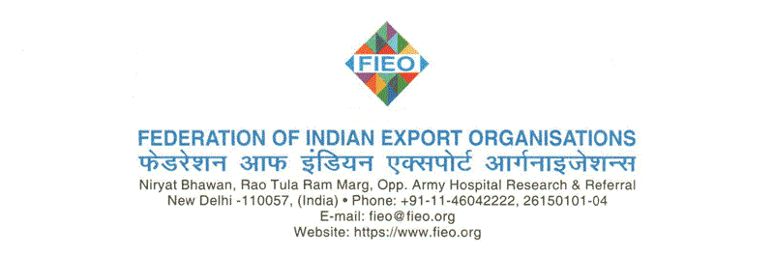
To,
FIEO/NR/2(5)/2024-25
October 09, 2024
Dear· Member(s),
10th Edition of POWERELEC NIGERIA 2025 at LAGOS
(Airfare Reimbursement up to INR 1,50,000/-)

We are pleased to inform you that FIEO is organizing participation of Indian companies in the PowerElec Nigeria in Lagos, Nigeria to be held as per the following schedule:
Event Dates : 13 – 15 January, 2025 (Monday to Wednesday)
Venue : Landmark Centre, Victoria Island, Lagos, Nigeria
Timings : 10:00 am to 05:00 pm (Local Nigeria Time)

India and Nigeria have strong and deep-rooted historical ties that stretch across economic and cultural spectrums. At present, India is Nigeria’s largest trading partner. The bilateral trade between India and Nigeria has grown over the years. India’s exports to the country stood at USD 3.6 Billion in 2023-2024. Nigeria with a population of 196 million is sharing borders with Benin, Niger, Chad and Cameroon.
Nigeria is the largest economy in sub-Saharan Africa, but limitations in the power sector constrain its growth. Nigeria is endowed with large oil, gas, hydro and solar resources, and it has the potential to generate 12,522 MW of electric power from existing plants.
THE EVENT:
POWERELEC NIGERIA is an exclusive B2B & Expo set for Indian Exporters to get connected with the key stakeholders & decision-makers in the Power & Electronics sector in the West African Region. Procurement managers and suppliers will get to interact with Indian exporters and will enable them to strike bulk deals to ensure seamless operations. It’s a win-win situation for all stakeholders in the sourcing business for the entire value chain.
- EXHIBIT PROFILE:

- FIEO Pavilion will showcase the following exhibit categories in the PowerElec Nigeria 2023:

- Ø Captive and Co-generation Plants, Geo Thermal, Thermal Power, Decentralised Generation, New & Renewable Energy Plants

- · Generators and Diesel Generating Sets
- · Wind and Solar Power Equipment
- · Electric Drives, Batteries, Inverters, UPS Systems

- Ø Transmission& Distribution Equipment

- · Transmission Lines, Towers & Accessories
- · Sub Station Equipment
- · Power and Distribution Transformers
- · Switchgear and Control gear
- · Measuring Instruments and meters
- · Cables and Conductors
- · Cabling and Wiring Products and accessories
- · Capacitors, Insulators, Insulation Materials and Electrical Components
- · Equipment for Alternate Sources of Energy

- Ø Utilisation, Controlling and Measuring Equipment

- · Household Electrical Appliances and Products
- · Safety Systems and Devices
- · Lighting Systems and Solutions, Lighting Fixtures and Accessories
- · Lamps and LEDs
- · Regulating and Control Equipment
- · Automation Systems
- · Building Automation Products
- · Rotating Machines
- · Energy Saving Equipment

- VISITORS PROFILE:

- · Utilities& IPP’s Public and Municipal Utility Owners & Managers
- · Government and Regulatory Executives
- · Independent Power Producers
- · Original Equipment Manufacturers
- · Plants& Project Management Power / Heat Plant Owners & Operators
- · Plant Service Sector
- · Project Developers & Managers
- · Engineers Design / Structural / Construction Engineers
- · Industrial Facilities Personnel Mechanical / Electrical Plant Engineers
- · Investors& Advisors Strategic and Portfolio Investors
- · Industry Consultants and Advisers
- · Energy Traders & Trade Press
- · Construction Engineers, Builders etc.

PARTICIPATION CHARGES:
The event is approved under Market Access Initiative (MAI) Scheme of the Ministry of Commerce & Industry, Govt. of India. After taking into consideration the grant from the Ministry, the participation charges are:
FIEO Members: @ 1,35,000/- INR *
FIEO Non-Members: @ 1,45,000/- INR *
Participation Fees includes built up stall 9 sqm (3m x 3m booth) having Elevated Fascia Branding with Company Name, Carpeting, Wall Panels, 3 lights, 2 chairs, one table, one socket, one dustbin, India pavilion branding
Note: This fee does not include sending display material, any additional fixtures & furniture in the booth. These are to be borne by the companies.
*INR 10,000/- extra for Corner Booth

Details for RTGS/NEFT Payment: HDFC Bank Ltd

Bank Name | HDFC Bank Ltd.
Bank Address | C-17, Anand Niketan, New Delhi-110021
Bank A/c | FIEO
Account No. | 50100330645443
MICR Code | 110240054
IFSC | HDFC0000336

NOTE:
As per DOC, a company can avail MAI assistance up to a maximum of three times (including past cases) for a particular event.
AIRFARE SUBSIDY:
Eligible companies will be entitled for reimbursement of economy class Airfare on submission of documents after the completion of the event. The amount of reimbursement shall be subject to the approval and quantum of funds approved by the Ministry for the said event maximum up to INR 1,50,000/- (Only One Person Per Company i.e. only to Director, Proprietor, Partner, regular officer of the company on senior managerial Position will be eligible for the Airfare Reimbursement).
VISA:
FIEO will issue the recommendation letter to the participants (Max 2 per company)
PAYMENT & REFUND POLICY:
The participation charges are non-refundable in any case. Interested members are requested to kindly send us their confirmation as per the Registration Form(s) enclosed along with the participation fee (Non-Refundable). The payment may be made only through NEFT/RTGS details of which may be shared on request latest November 29, 2024. It may be informed that we have limited stalls and preference will be given on the basis of first-cum-first- served basis and on receipt of full participation fee. FIEO reserves the right to select the participants.
In case of any further queries, you may contact FIEO at +91-011-46042117/2157/2178 or 9899823043/8586848676 or by e-mail at ashishjain@fieo.org; sunitatatwal@fieo.org; nishantkatyayan@fieo.org.
Warm regards,
Yours sincerely

Dr. Ajay Sahai
Director General & CEO

